### Prototype Design

### 

#### Lobby Queue

The Lobby Queue located on the left is where the currently playing song and the songs to be played next will be displayed.

#### Lobby Top Tracks

This is where the top Spotify tracks of all the users in the room will be displayed. The host view has Queue buttons whereas the customer view has Vote buttons.

#### Room Lobby

The room lobby contains a list of all of the users within the room, it will show the host of the room at the top and all the other users underneath. By clicking on a user’s name you will be redirected to their Spotify page.

#### Playback Footer

#### The Playback Footer on the bottom is where the host will control the songs status whether its playing/pausing, altering the volume or skipping the song. Other customers will only be able to change the volume on their end.

### Queuing and User Playback

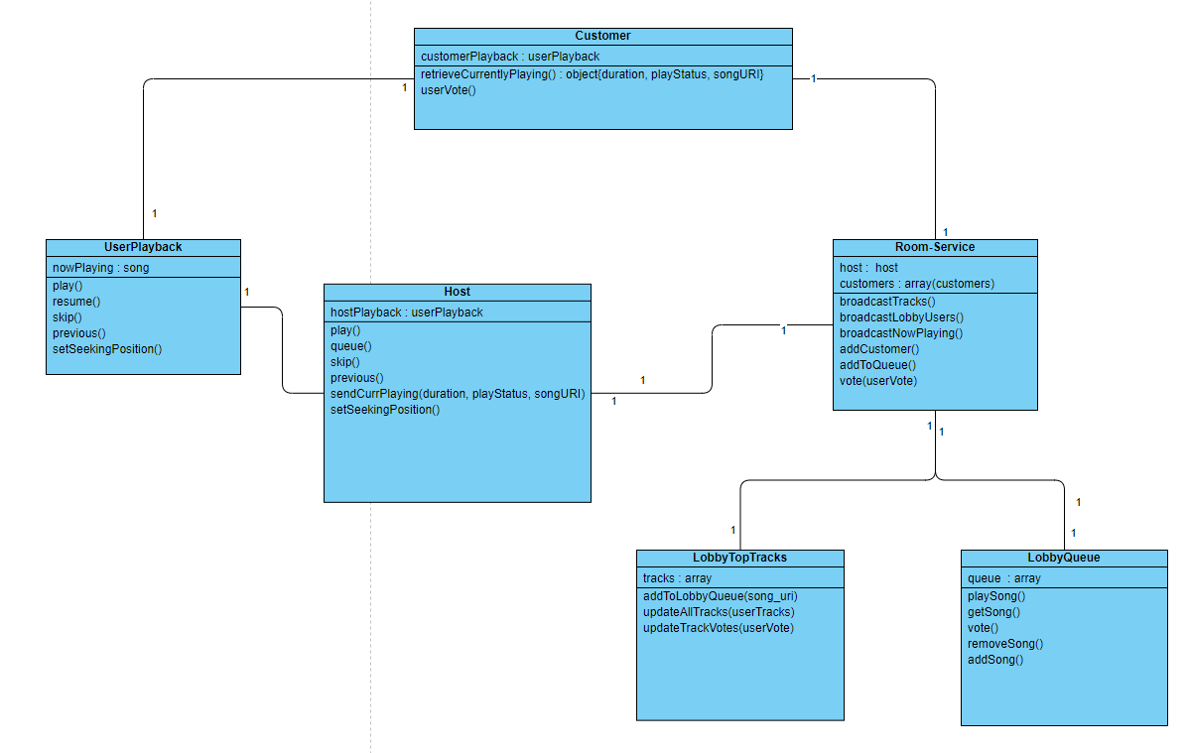

#### UserPlayback

User playback is a service made available to us via spotify. Using Spotify's API we can play, pause, skip, go back to the previous song, as well as get information about the currently playing song. Each of our users has their own UserPlayback.

#### Customer

A customer is a member of the room, they do not have power over the rooms currently playing music. The customer gets information of the currently playing music from the room-service containing: the current song, the seeking position and if the music is playing or paused. This information is then used to set the customers UserPlayback. A customer is also capable of voting for songs they want to hear from the LobbyTopTracks, this will move the song they want to hear nearer to the top.

#### Host

The host is a user who is in charge of a room. Only the host of a room has access to the playback functions. The host can play and pause the current playing song, set the currently playing song’s seeking position, skip to the next song, and skip to the previous song. They can queue up a song for the room. They also send information about the currently playing song status to the room-service.

#### LobbyTopTracks

The lobby top tracks is the track list which is shown to the users and host at the centre of the user interface. The lobby top tracks displays the track album art, track name, artist and album it is a part of. The lobby top tracks also allows the host to queue songs using the button at the end of each track row; this will push the song selected onto the lobby queue, however this function is not available to the users in that room.

#### LobbyQueue

The lobby queue is a queue which is created by the host when queueing up songs from the LobbyTopTracks class. This queue contains an array attribute of several songs of which are added by the host. Once a song has finished playing, the song at the top of the queue will start playing. To check which song to play next the LobbyQueue will use the getSong() operation to play the next song for the user. There will also be a vote feature which will override which song is next in the queue.

#### Room-service

The room-service class displays both the host and the customers within the room. It displays the top tracks from each individual in the room to both host and users, which users are in the lobby and the currently playing song. It is also responsible for adding customers to the user list and songs to the lobby queue. Alongside, it tracks the votes made by users to queue a specific track to the queue.